Basic Harvard Outline Format – This is also good for taking notes. Use phrases and short clauses, not just single words.

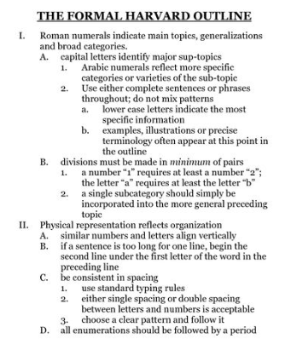
BYZANTINE CHRISTIANDOM: BUILDING ON THE ROMAN PAST
I. THE BYZANTINE STATE
A. Byzantine Empire never regained the size of the Roman Empire.
1. Syria, Palestine, North Africa, Spain fell to Arab/Muslim control.
B. Political authority remained tightly centralized in Constantinople.
1. Emperor claimed to be God’s worldly representative.
2. Very fancy central court.
3. Government collected taxes, maintained order and suppressed revolts.
4. Empire steadily lost land from 1085 on.
II. The Byzantine Church and Christian Divergence
A. The emperor served as both head of state and religion (Caesar and Pope rolled into one)
1. Appointed a Patriarch to be head of the church.
2. Orthodox Church considered part of government. No separation of church and state.
i. Orthodox= “Right thinking”
3. Emperor seen as chosen by God.
B. Orthodox church split from the Roman Catholic Church.
1. Reflected rivalry between the Byzantines and new Western European kingdoms.
2. Byzantines made changes to the church.
i. favored Greek over Latin.
ii. prohibited use of icons in church.
iii. priests allowed to grow beards and marry.
iv. leavened bread (Orthodox) vs. unleavened bread (Catholic) for Communion.
v. did not believe the Pope to be infallible.
vi. leaders of both churches excommunicated each other.
III. Byzantium and the world
A. Interacted and competed with Persia.
1. This weakened both empires and made the rise of Islam easier.
i. Developed a flamethrower-like weapon to fight off Muslims.
B. Trade
1. Traded with Western Europe, Russia, the Islamic world, Central Asia and China.
i. Traded gemstones, fabrics, textiles, purple dyes, precious metals
ii. Wanted silk.
iii. Transmitted ancient Greek knowledge to the Islamic world and Christian West.
iv. Spread Orthodox Christianity and the Cyrillic alphabet to the Slavs in the Balkans and Russia.
IV. The Conversion of Russia
- Civilization popped up in Ukraine (Kievan Rus).
- Originally polytheistic.
- Prince Vladamir of Kiev chose to affiliate with the Orthodox Church to unite diverse peoples under one religion and culture, and link Rus to the wider world. i. Rejected Islam because he liked to drink alcohol.
ii. Orthodox Christianity is popular in Russia to this day.
3. Russia saw itself as the third Rome and final protector of Orthodox Christianity.

