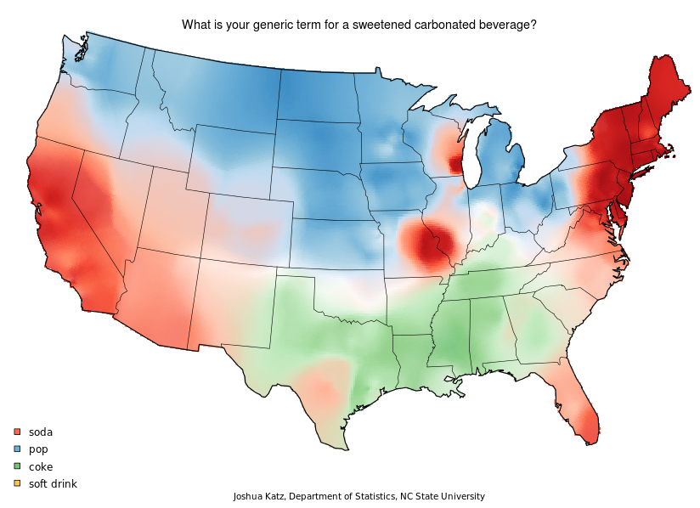

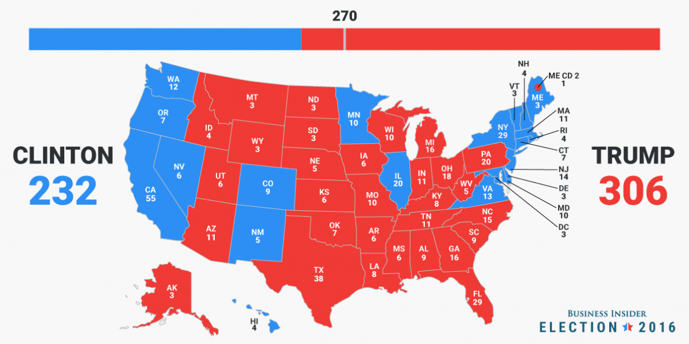

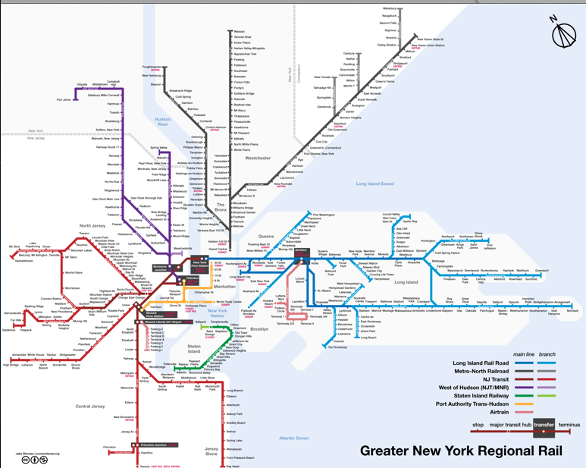
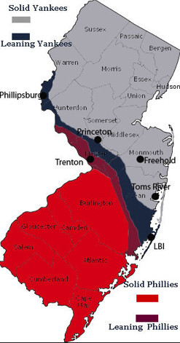

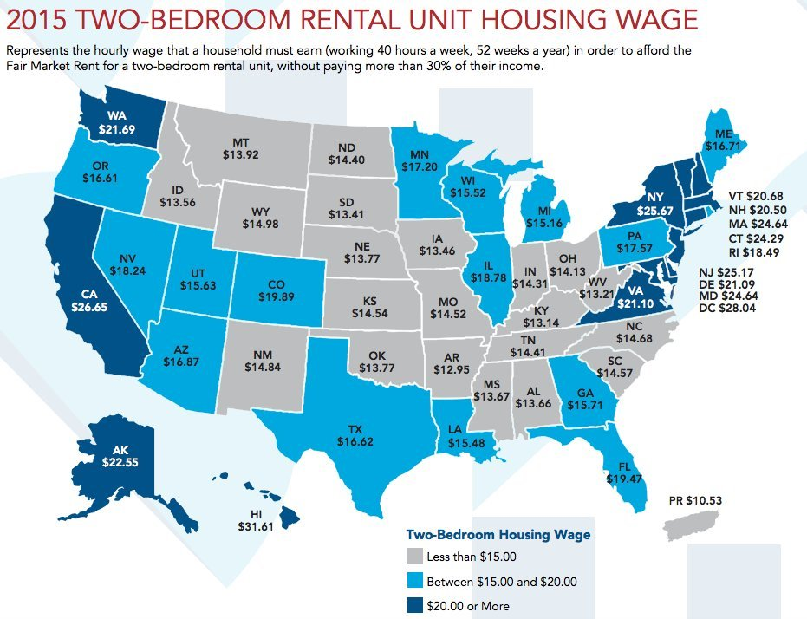

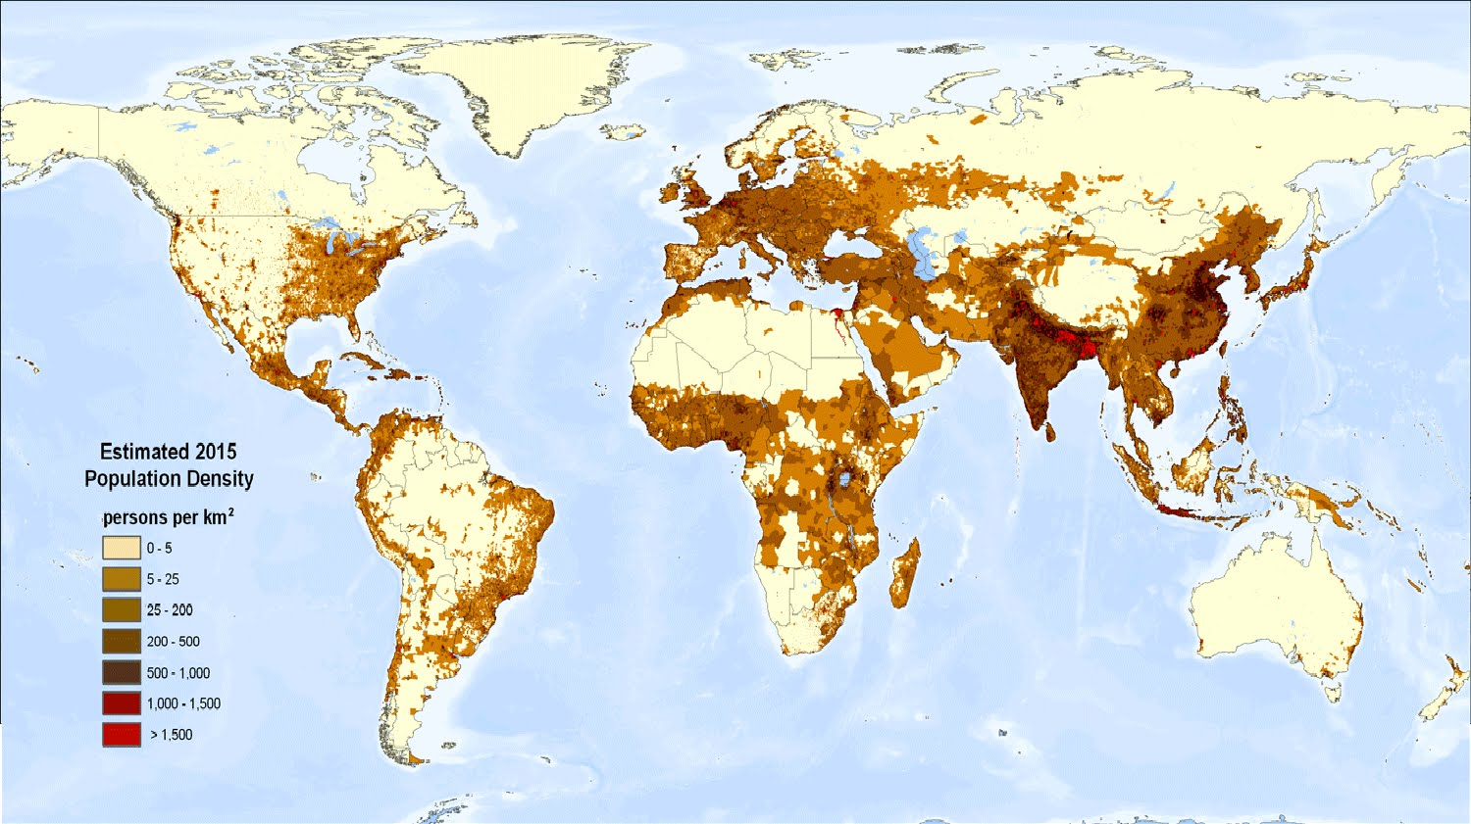

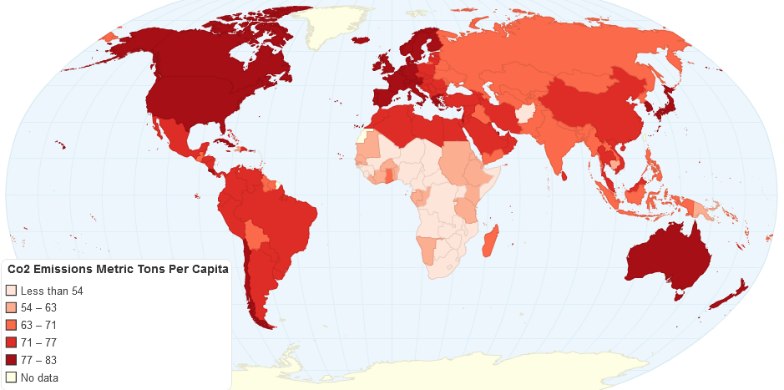

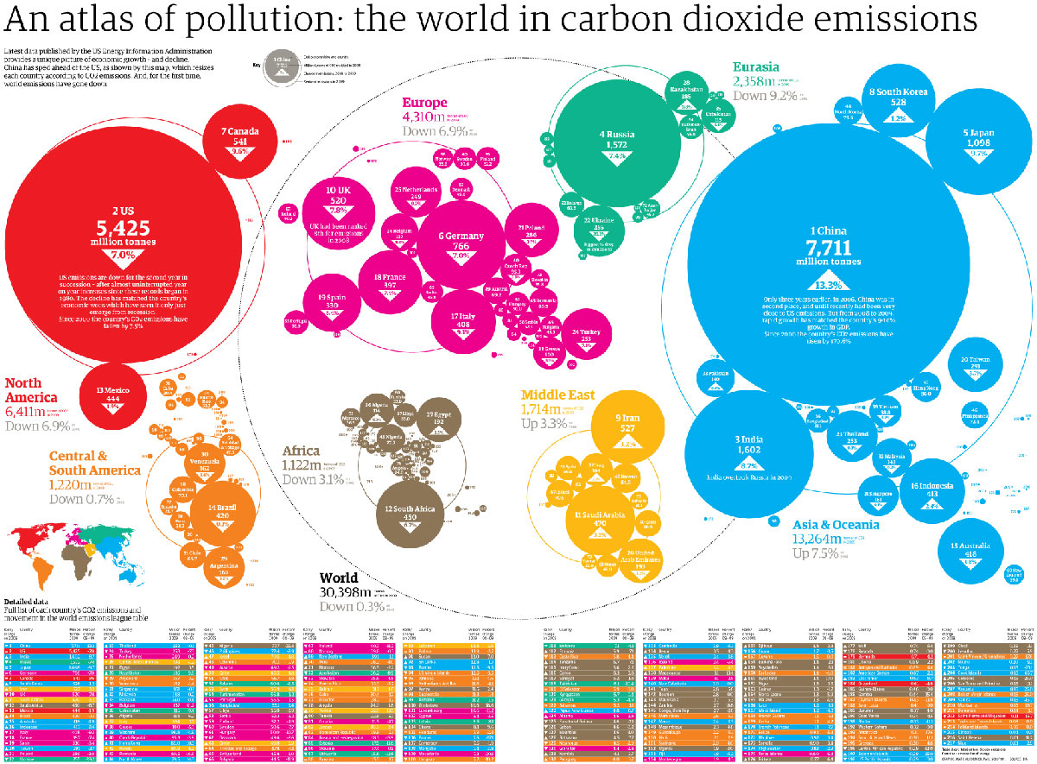

Fun With Maps

AIM: How can we use different types of maps?

Do Now: Read the reading below and answer the following question.

Types of Maps
There are several types of maps. Each type shows different information. Most maps include a compass rose, which indicates which way is north, south, east and west. They also include a scale so you can estimate distances. Here's a look at some different types of maps.
Climate maps
give general information about the climate and precipitation (rain and snow) of a region. Cartographers, or mapmakers, use colors to show different climate or precipitation zones.
Economic or Resource maps
feature the type of natural resources or economic activity that dominates an area. Cartographers use symbols to show the locations of natural resources or economic activities. For example, oranges on a map of Florida tell you that oranges are grown there.
Physical maps
illustrate the physical features of an area, such as the mountains, rivers and lakes. The water is usually shown in blue. Colors are used to show relief—differences in land elevations. Green is typically used at lower elevations, and orange or brown indicate higher elevations.
Political maps
do not show physical features. Instead, they indicate state and national boundaries and capital and major cities. A capital city is usually marked with a star within a circle.
Road maps
show major—some minor highways—and roads, airports, railroad tracks, cities and other points of interest in an area. People use road maps to plan trips and for driving directions.
Topographic maps
include contour lines to show the shape and elevation of an area. Lines that are close together indicate steep terrain, and lines that are far apart indicate flat terrain.

- What type of map is “Map A”?________________________

- What would you name Map A?

- In which part of the United States do people use the name “Coke” as a generic term for soda?

4. Which parts of the country use the term “soda”?

- What does “Map B” show?

- How many states did President Trump win in 2016?

- How many states did Hillary Clinton win in 2012?

- What type of map is “Map B”?

- What does “Map C” show?

- In which three states does it cost the most to rent a two-bedroom apartment and how much does it cost?

- In which three states does it cost the least to rent a two-bedroom apartment and how much does it cost?

- What is shown in map D?

- In which world regions do most people live?

- Why are there large regions in S. America, Central Asia and Northern Africa with very low population densities?

- What type of map is Map E?

- Which transit systems appear to have stops in New Jersey?
- How does one get to Long Island?

- What would you name Map F?

- Approximately where would you say residents of New Jersey change from Phillies fans to Yankees fans?

- Why does it make sense for the transition area to appear in that part of the state?

- What does map G show?

- Which countries/regions produce more carbon dioxide pollution per person than any other?

- Which two countries produce more carbon dioxide overall than any other?

- What might account for the low Carbon Dioxide output in Sub-Saharan Africa?

