Vocabulary to Know
Column 1 Column 2 Column 3
1. Bracero Program 14. forced migration 27. colonization
2. refugee camps 15. voluntary migration 28. guest workers
3. remittances 16. human trafficking 29. migration
4. reverse remittances 17. laws of migration 30. islands of development
5. cyclic movement 18. gravity model 31. Russification
6. periodic movement 19. push factors 32. refugees
7. activity spaces 20. pull factors 33. internally displaced persons
8. asylum 21. distance decay 34. repatriation
9. nomadism 22. step migration 35. genocide
10. transhumance 23. intervening opportunity 36. immigration laws
11. international migration 24. deportation 37. selective immigration
12. emigration 25. kinship links 38. internal immigration
13. immigration 26. chain migration 39. immigration wave

Unit 3: Migration pgs. 60-66
Key Question #1: What is migration?
- What percentage of Mumbai residents live in slums (shanty towns)?

- How did politicians in Mumbai encourage the growth of Shanty Towns and why did they do it?

- Identify and explain the two major recent refugee flows explained in the prologue on page 61.

- How do remittances work?

- Looking on the map on page 62, identify the five countries that have sent the most legal immigrants to the United States from Latin America in the years from 1982-2012. How many immigrants did each of these countries send?

- How has the development of a border fence along the U.S./Mexico border affected the route of illegal immigrants?

- Fill out the chart below
Define the Term
Give an Example

- Explain the difference between nomadism and transhumance.

- What was the major migration stream in the United States between 1900 and 1970?

- How did the recession of 2007-2008 affect internal migration in the United States?

- Using the map on page 66, Identify the five states and territories that have experienced the highest population growth as well as the two states and territories that have seen their population drop between 2010-2012.
Unit 3: Migration pgs. 66-73
Key Question #2: Why do people migrate?

- Give 2 examples of forced migrations that originated in Europe from the 19th century.

- How does Veronica Lawson’s “cooperative conflict bargaining process”, mentioned on page 67, work?

- Explain the difference between forced migration and voluntary migration.

- According to the map on page 68, where were most African slaves sent during the Trans-Atlantic Slave Trade?

- How has the Trans-Atlantic Slave Trade affected the culture of Benin in Africa and Bahia Brazil?

- How is human-trafficking forced migration?

- Summarize Ravenstein’s laws of migration.

- How does the gravity model relate to distance-decay?

- How do intervening opportunities relate to step-migration?

- Why are push-factors more concrete than pull-factors?

- Choose one armed-conflict described on page 71, and explain how it led to migration and to where the migrants went.

- Name one environmental crisis not described in this section that has led to forced migration.

- How do kinship links lead to chain-migration?

14. Why did the United States send away the climate refugees from Monserrat?

Unit 3: Migration pgs. 73-86
Key Question #3: Where do people migrate?

1. Trace and color code the major migration flows shown in figure 3.10.
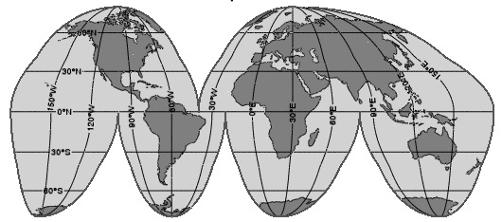
2. In which two areas of the world did the British send South Asians as indentured servants?

3. Which countries do guest workers typically flock to in Europe, and from where do they leave?

4. Which countries do guest workers flock to in Southeast Asia, and from where do they leave?

5. Why did Indonesia order all of it’s citizens who were in the Middle East as guest workers to come home in 2003?

6. Why did the “islands of development” in Nigeria reverse the flow of migration in the 1980s?
7. Where have many Chinese laborers ended up as a result of famines in the late 1800s and early 1900s.

8. Explain both migrations flows that resulted from British policy in Palestine/Israel.

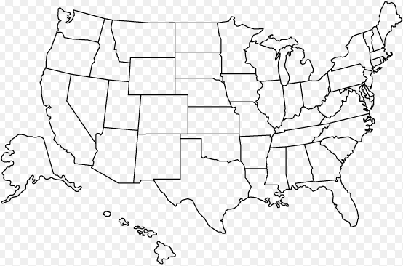
9. To where has the center of U.S. population shifted? Highlight the shift on the map below. Explain why the center of population has shifted the way it did.

10. Where did African Americans migrate in the 1920s and why did it reverse in the later 20th century?

- Explain Russification.

- What is the difference between a Refugee and an Internally Displaced Person?

- Which countries were affected by the Hutu-Tutsi conflict in Rwanda?
- Why do most refugees end up migrating to other poor countries?

15. Why is the Syrian Refugee Crisis relevant in the world today? (Look it up on the internet.)

- Why are Kurds and Afghans suffering from Refugee criseses?

- Who was involved in the conflict in Darfur, Sudan?

- Why is Bangladesh in danger of becoming ground zero for climate refugees?

Unit 3: Migration pgs. 86-89
Key Question #4: How do governments affect migration?

- The book says that, “In Europe, right-wing political parties whip up anti-immigrant sentiment.” Use the internet to explain the significance of the National Front in France and Golden Dawn in Greece.

- Give one example of a major border fence from ancient times and explain that country’s dual goals for both its citizens and foreigners.

- Where are two current controversial walls that were built to keep foreigners out?

- Who did the Australian government want to keep out starting in 1901, and when did they lift those restrictions?

- How was the first wave of immigration in the early 1800s different than the second wave in the late 1800s in the United States?

- At what time in our history did Latin Americans start arriving in greater numbers than Europeans to the United States? When did Asians surpass Europeans?

- Why did immigration to the United States drop off after WWI? (State 2 reasons)

- Explain selective immigration.

- Why was “Operation Liberty Shield” criticized and ultimately ended?

