Projections
AIM: Why do we use maps?
Do Now: Take out your 5 themes of geography worksheet for the last segment.

- What can a map show us?

Map Basics - A map is a two-dimensional or flat-scale model of the earth’s surface, or a portion of it.
Vocabulary Terms
Scale –

Key/Legend –

Compass Rose -

- Are maps 100% entirely accurate?

Distortion Notes

Mercator Projection
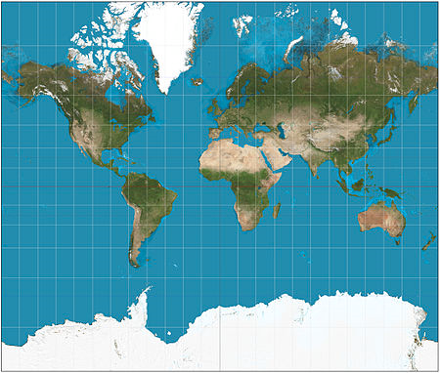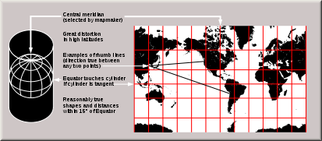
Developed by Gerardus Mercator in 1569, it is a projection that was favored by ships captains during sea travel because it preserved direction. However, the land masses get more distorted the closer you get to the poles.
As a result, Greenland, an island country, looks larger than Africa, the world's second largest continent.

Robinson Projection
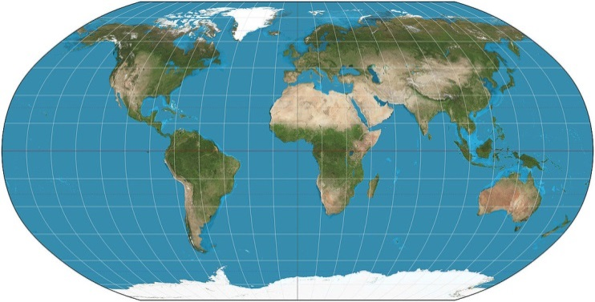
The Robinson Projection attempts to preserve the shape and size of the landmasses better than the Mercator Projection.

Winkel-Tripel Projection
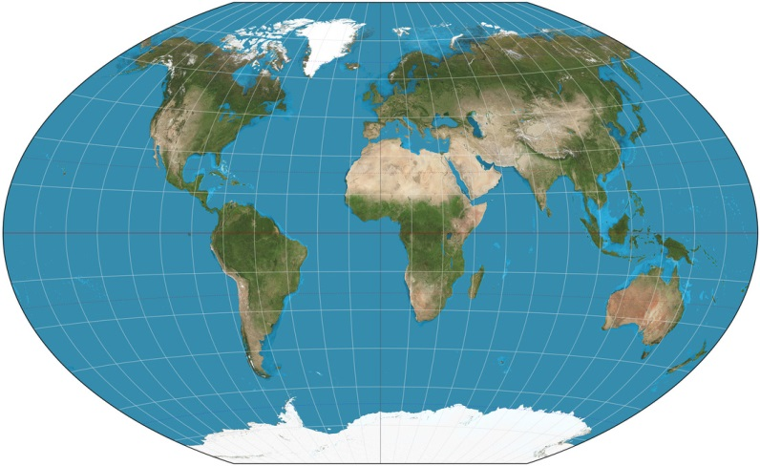
The Winkel-Tripel projection is slightly more accurant than the Robinson at preserving the size and shape of landmasses, and is the favored projection for world maps today.

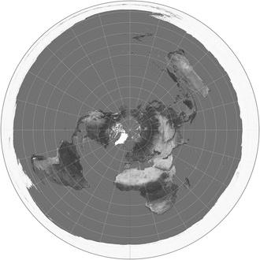

Azimuthal Projection
An Azimuthal Projection is any map projection in which a region of the earth is projected onto a plane tangential to the surface, typically at a pole or the equator.

Interrupted Projection
The Interrupted Projection does the best job of preserving the relative size of the landmasses; however, it butchers our oceans.
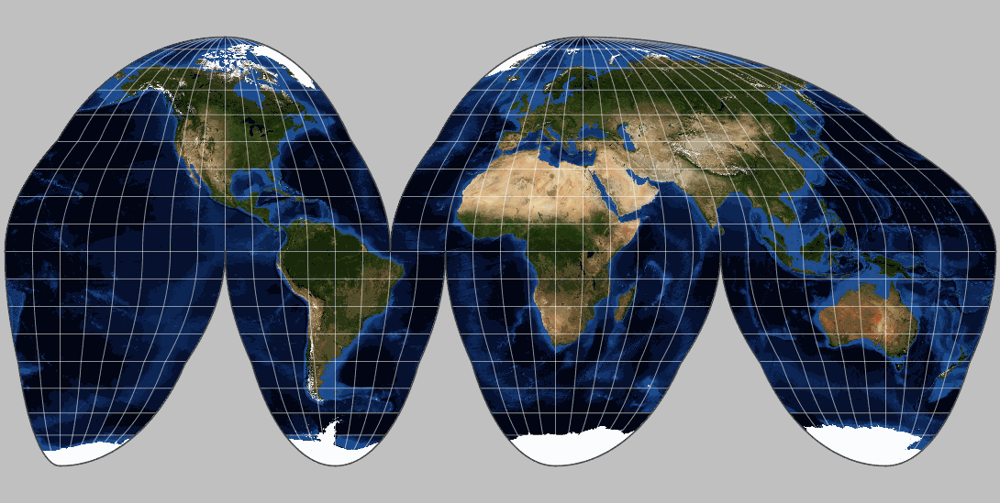
- Aside from distorting the size of the land-masses, what are other ways the Robinson, Winkel-Tripel, and Mercator projections get wrong in their depiction of the earth?

