Rohingya refugee horror stories 'beyond comprehension'
30 December 2017
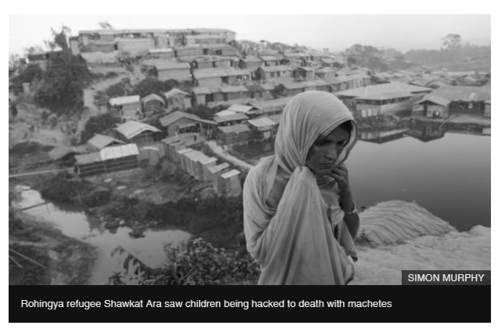
Simon Murphy has documented human rights abuses in countries including the Democratic Republic of Congo, South Sudan, Ethiopia and Colombia.
But nothing prepared him for a trip to Bangladesh with the Scottish Catholic International Aid Fund (SCIAF).
The charity has so far helped more than 40,000 families who have fled Myanmar.
But Simon, from Glasgow, told how many have been left traumatised after witnessing atrocities ranging from sexual violence to mass murder.
He said: "One girl I photographed saw her parents being killed.
"Others told how they had witnessed villages being torched, children being raped and families being butchered with machetes.
"The Rohingya have lost so much and their experiences are beyond comprehension."
Shawkat Ara, 38, hid in the jungle and watched her village burn after it was attacked by soldiers in the middle of the night.
She said: "The military told the young boys to stand in a line and told them to run.
"When they were running they rushed them from behind and they were falling in ditches.
"Some were cut into pieces and thrown into ditches.
"They were all between 10 and 12 years old.
"The military were actually playing with the boys.
"They were telling them to run and then cutting them."
Although she survived the slaughter Ms Ara, who is five months pregnant, lost her son and parents to hunger as the family fled.
Despite a recent agreement with the Burmese government for repatriation, refugees continue to arrive in Bangladesh.
But Mr Murphy said the situation facing those who brave the dangerous border crossing is desperate.
He said: "New arrivals are taken to a reception area near the harbour.
"They are tired and hungry and have witnessed unspeakable horrors but they have to stay in wooden pens until they are processed.
"It can take up to 48 hours for this to happen and there is a real sense of hopelessness."
Conditions in the camp are also bleak and there are genuine fears about what will happen when the heavy rains come.
SCIAF director Alistair Dutton said: "Over 620,000 people have arrived since August alone, overwhelming the camps and those trying to help.
"After 20 years of working in some of the world's worst humanitarian emergencies, I'm deeply worried by the conditions I've seen.
"Families are living in crowded, makeshift huts made of bamboo and plastic that provide little protection from the baking heat of the sun or the cold of winter nights."
Mr Dutton warned many shelters are precariously perched on muddy hillsides and at risk of being washed away in the rainy season.
He also expressed concerned about the alarming sanitary situation.
Mr Dutton said: "Raw sewage is seeping into people's huts where they cook and sleep.
"Filthy water runs along channels between huts, collecting in stagnant, polluted ponds dotted around the camps."
He said the refugees' graphic accounts of the horrors which forced them to flee beggar belief.
Mr Dutton added: "The Rohingya have experienced unimaginable, barbaric crimes against humanity.
"Many are traumatised, having seen members of their family and loved ones butchered by machetes, shot or burned alive.
"Everything they owned was stolen or destroyed.
"Now they're in Bangladesh with absolutely nothing and desperately need our help."
The SCIAF director said Scottish donations, which so far exceed £160,000, are saving lives in Bangladesh.
To date the charity, working with its partner Caritas Bangladesh, has provided rice, lentils, sugar and oil, as well as plates, saucepans, glasses and cooking utensils to more than 40,000 families.
And in the coming days it will start to distribute blankets and sleeping mats to 14,600 families so they can keep warm at night.
But Mr Dutton urged world leaders to do more as the average length for someone to remain a refugee is 17 years.
He added: "Despite all the efforts by diplomats and world leaders to negotiate a return, it is likely that the Rohingya will be in exile for many years.
"The international community must prepare for this and ensure that the conditions in the camps improve.
"Otherwise, an already appalling situation in Bangladesh will get much, much worse."

