Unit 1: Introduction to Human Geography pgs. 1-5
Key Question #1: What is Human Geography?

- Why is Kenya’s most productive farmland devoted to tea and coffee rather than useful food products?

- Why is Kenya’s export revenue from coffee and tea important to the government?

- Why is fieldwork important to geographers?

- Define globalization as it is defined in the text.

- Define “scale”.

- What are the problems inherent in reducing the world to “local” and “global”?

- What are some of the different levels of scale?

Unit 1: Introduction to Human Geography pgs. 5-11
Key Question #2: What are geographic questions?

- What is the difference between physical geography and human geography?

- Why are geographers interested in spatial arrangements and spatial distribution of phenomena?

(CASE STUDY: CHOLERA)
- Define “pandemic” and explain the typical conditions where cholera thrives.

- What is the difference between a pandemic and an epidemic?

b. How did Dr. Snow figure out the cause of Cholera?

(THE FIVE THEMES)
- How can geographers use location theory to determine where it is best to build a particular store?

- Give on example of human-environmental interaction where humans have made a decision that impacted society in a negative way.

- Define “sense of place”.

- A. Shade in the areas in the maps below where students from California and Pennsylvania were most similar in answering where they would like to live.
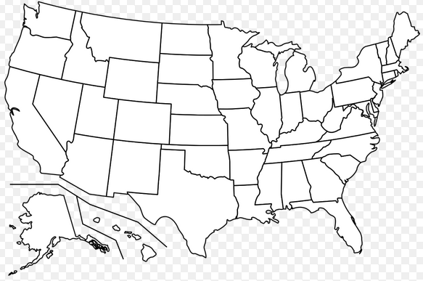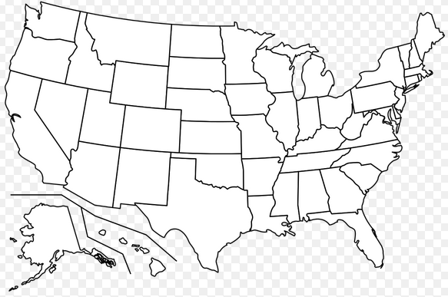
Students from California Students from Pennsylvania

B. Where were students least likely to live in both cases?

C. Why do you think the students from Pennsylvania were more willing to live in California than students from California were willing to live in Pennsylvania?

- Explain the connection between spatial interaction and distance.

- Define “landscape”

- Define “cultural landscape”

Unit 1: Introduction to Human Geography pgs. 11-17
Key Question #3: Why do Geographers Use Maps and What Do Maps Tell Us?

- Explain the difference between thematic maps and reference maps.

- How do global positioning systems work?

- Explain how Fredericksburg, Virginia has changed it’s relative location.

- How are mental maps formed?

- Which of our mental maps are the most accurate?

- Define “terra-incognita”.

- Define “remote sensing”.

- Define “geographic information systems (GIS)

- How can training in GIS technology lead to lucrative jobs?

(GUEST FIELD NOTE)
- How can GIS aid in the fight against Dengue fever?

Unit 1: Introduction to Human Geography pgs. 18-26
Key Question #4: Why Are Geographers Concerned with Scale and Connectedness?

- How does scale affect observation?

- How is the local map that show’s the median family income of neighborhoods in Washington D.C. more accurate than the map that shows the median family income by state and province?

- Complete the chart below which details types of regions identified by geographers.

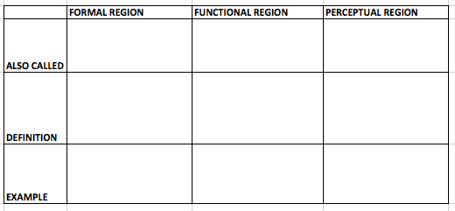
- How have some Americans altered their definition of the perceptual region, “The Middle East” since the terrorist attacks of 9/11/2001?

- What methods did Wilbur Zelinsky use when constructing his map of the 12 major perceptual regions in the United States?

- Define “Culture” as it is defined in the book, and give an example of a cultural trait in your culture.

- How is culture a system of meaning?

- Define “Culture Complex”.

- How can two regions act as a cultural hearth for the same idea or invention?

- How can cultural taboos inhibit the spread of an idea? Give an example.

- Explain how the brand “Under Armour” spread.

- Fill in the chart below based on information from the text.
 |  | Diffusion
 | hearth
 | relocation diffusion
Expansion | hierarchical diffusion
 | contagious diffusion
Diffusion | stimulus diffusion

Unit 1: Introduction to Human Geography pgs. 26-28
Key Question #5: What are Geographic Concepts & How are they Used in Answering Geographic Questions?

- Very carefully define the following terms.
- Environmental Determinism -

- Possibilism -

- Cultural Ecology –

- Why do geographers reject Environmental Determinism in favor of Possibilism?

- What are the limitations with Posibilism?

Limitations of the Textbook Unit 1:

Terms to Know:
Toponym Situation Physiological Density
Cartography Density Concentration
Site Arithmetic Density Space-Time Compression
Distance-Decay Tobler’s First Law of Geography

- How many time zones are on Earth, and how are they divided?

- How does Tobler’s First Law of Geography relate to distance decay?

- How has modern technology played a role in globalization?

- Draw the Prime Meridian and the International Date Line. What is the longitude of the International Date Line?

