Vocabulary to Know
Column 1 Column 2 Column 3
Gender residential segregation place
Identity succession gendered
Identifying against sense of place queer theory
Race ethnicity dowry deaths
Racism space barrioization

Unit 6: Identity: Race, Ethnicity, Gender and Sexuality pgs. 117-126
Key Question #1: What is Identity and How are Identities Constructed?

- Give five examples of jobs in the U.S.A. that are considered “gendered”.

- What do you identify against when creating your identity?

- How did European colonizers identify natives of Africa, Asia, and the Americas when they created their own identity?

- Why do people living closer to the equator have darker skin while people further from the equator have lighter skin?

- Why isn’t ethnicity often assigned the same way as race?

- How has the U.S. census adjusted its definition of “Hispanic” and why?

- Define residential segregation.

- Identify the three most racially segregated cities for Asia/Pacific Islanders in the United States.

- Where are the least segregated cities for Native Americans located in the United States?

- How do real estate agents perpetuate residential segregation?

- List one of your identities at each of the following scales.

- Individual

- local

- regional

- national

- global

- Explain what succession is and give an example for how it has worked in New York City.

Unit 6: Identity: Race, Ethnicity, Gender and Sexuality pgs. 127-130
Key Question #2: How do places affect identify, and how can we see identities in places?

- How does one infuse a place “with meaning and feeling”?

- How can ethnicity be connected to place?

- To what extent is the term “Swiss-American” misleading?

- Give 5 examples of post WWII ethnic conflicts.

- How did a Chinatown develop in Mexicali, Mexico?

- How can places be gendered? Give 3 examples of “male gendered spaces” and 3 examples of “female gendered places”.

- Why was a “Gay and Lesbian Atlas” of the United States only possible starting around 2010?

- Why are gay and lesbian couples of the baby boom generation migrating?

Unit 6: Identity: Race, Ethnicity, Gender and Sexuality pgs. 130-1142
Key Question #3: How does geography reflect and shape power relationships among groups?

- How do power relationships affect cultural landscapes?

- How was the Jim Crow era an example of power relationships?

- Why is women’s work often undervalued?

- Explain what the author means when they refer to the informal economy.

- Why do women worldwide only control 1% of the world’s wealth?

- Why are some families in Pakistan more prone to contracting dysentery than others?

- How do rates of who contracts HIV/AIDS different in Sub-Saharan Africa compared to Europe and the USA?

8, Use figure 5.15 to shade in the areas where Gender Inequality is “Very High”.
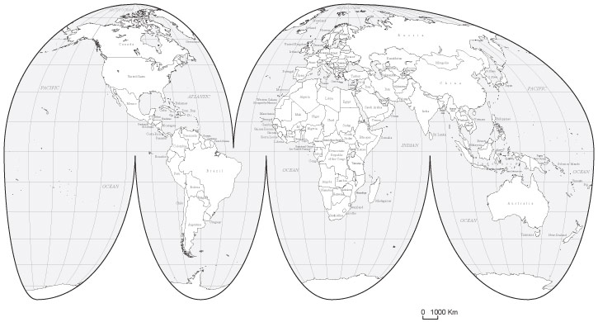

- Why do women in Sub-Saharan African villages often struggle to survive after the men leave?

- Which world country has the most female representation in it’s elected government and why?

- What are dowry deaths, and why do they persist?

- How does scapegoating relate to cities with multiple-ethnicities?

- Explain the “model minority” myth and how it relates to Asian groups in the United States.

- Explain barrioization.

