Vocabulary to Know
Column 1 Column 2 Column 3
Commodity chain context export processing zones (EPZs)
Break-of-bulk location neo-colonialism maquiladoras
Gross national product (GNP) structuralist theory special economic zones
Gross domestic product (GDP) dependency theory NAFTA
Gross national income (GNI) dollarization desertification
Per capita GNI world-systems theory island of development
Formal economy three-tier structure NGOs
Informal economy trafficking microcredit program
Digital divide structural adjustment loans
Millennium Development Goals Washington Consensus
Modernization model neoliberalism

Unit 10: Development pgs. 288-296
Key Question #1: How is development defined and measured?

- Why did Timbuktu transform from a renowned intellectual center to an impoverished town?

- Why doesn’t development necessarily lead to happiness?

- Why is GNI per capita limited in its ability to give us information?

- What is the difference between GNP and GNI?

- Explain the digital divide.

- Where are most of the countries with a high young dependency ratio located?

- What does the Human Development Index (HDI) measure?\

- Using your prior knowledge, how does the HDI relate to Wallerstein’s World Systems Theory?

- Explain the five stages of Walt Whitman Rostow’s modernization model (Take-off Model of Economic Development)

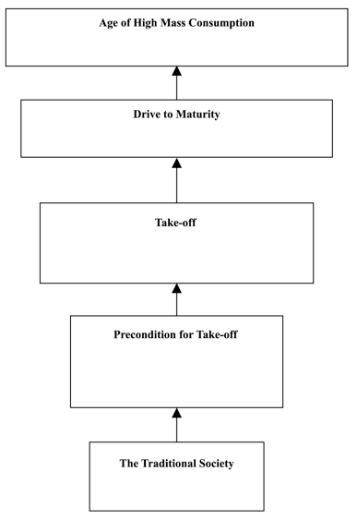

10. How is the modernization model flawed?

Unit 10: Development pgs. 296-298
Key Question #2: How does geographical context affect development?

- Describe neo-colonialism.

- How does structuralist theory work and how does it fit with World Systems Theory?

- How does dollarization both help and hurt countries like El Salvador?

- According to Wallerstein, why is the “How” of agriculture more important than what is produced?

Unit 10: Development pgs. 298-305
Key Question #3: What are the barriers to and the costs of development?

- How did Rwanda increase attendance in primary school and why isn’t that increase leading to systematic change in the educational levels of the country?

- How does the Bolsa Familia conditional cash transfer program in Brazil work?

- Why are girls more likely to be victims of human trafficking than boys?

- Why do some groups consider the structural adjustment loans given by the IMF and the World Bank to be more harmful than helpful?

- How does neoliberalism work?

- Why do peripheral countries have a hard time establishing and maintaining democracies?

- How do technological improvements in agriculture hurt the environment?

- What is an EPZ?

- Why did NAFTA lead to an “explosion” in the number of maquiladoras, and how has that affected manufacturing in the United States?

- Why is desertification occurring in Sub-Saharan Africa?

- How does tourism both help and hurt developing countries? Is the payoff worth it?

Unit 10: Development pgs. 305-311
Key Question #4: How do political and economic institutions influence uneven development within states?

- Where are some areas of economic isolation and stagnation in the ISA?

- Why are farmers in Wisconsin better off than farmers in rural Appalachia?

- How does the U.S. quota market affect where manufacturers build their factories?

- Why did Nigeria move its capital city?

- Why did Port Gentil in Gabon become an island of development?

- How do NGOs work?

7. Why are microcredit loans by NGOs valuable to poor people in LDCs?

